

**Front - End UI/UX Mini Project**

**To-Do List Application**

1. **Introduction :**

* **Project Title:** *To-Do List Application*
* **Submitted By**: 
  + *2462323 - Darren Samuel D’Cruz -* [*darren.samuel@btech.christuniverityuniversity.in*](mailto:darren.samuel@btech.christuniverityuniversity.in)
  + *2462345 - P. Kamuel Shawn -* [*p.kamuel@btech.christuniversity.in*](mailto:p.kamuel@btech.christuniversity.in)
  + *2462333 - Joel Jacob Roji -* [*joel.jacob@btech.christuniversity.in*](mailto:joel.jacob@btech.christuniversity.in)
* **Course**:  *UI/UX Design Fundamentals*
* **Instructor Name**: *Mrs. Nagaveena*
* **Institution**:  *Christ (Deemed – to – be) University, Kengeri Campus*
* **Date of Submission**: *25/09/2025*

**2. Abstract**

This project presents a responsive To-Do List Application that helps users manage tasks effectively. Unlike simple checklist apps, it integrates task categorization, priorities, deadlines, tags, filters, statistics, and progress tracking. Built with HTML5, CSS3, Bootstrap, JavaScript, and jQuery, the application ensures data persistence using LocalStorage. Its interface emphasizes clarity, usability, and adaptability with a built-in light/dark theme toggle.

**3. Objectives**

* Create a structured task management interface
* Provide options for categories, priorities, due dates, and tags.
* Enable search and filter functionality for easy navigation.
* Offer real-time progress tracking and quick stats.
* Implement dark/light mode for accessibility.
* Ensure data persistence using browser storage.

**4. Scope of the Project**

* Focus on front-end development only.
* Works across desktop, tablet, and mobile devices.
* No external backend or database integration.
* Stores task data locally using LocalStorage API.
* Uses Bootstrap and jQuery for rapid development and responsiveness.

**5. Tools & Technologies Used**

| Tool/Technology | Purpose |
| --- | --- |
| HTML5 | Provides webpage structure and semantic layout |
| CSS3 | Handles styling, colors, layout and responsive design |
| JavaScript | Adds interactivity, dynamic updates and drag and drop functionality |
| Bootstrap 5 | Ensures responsive design with prebuilt components |
| Bootstrap icons | Supplies modern icons for actions |
| jQuery UI | Adds sortable task functionality |
| Local Storage API | Persists tasks across browser sessions |

**6. HTML Structure Overview**

* Defines task input fields (text, category, priority, due date, tags).
* Uses <div>, <ul>, <li> for organizing tasks.
* Provides semantic sections for input, list, stats, filters, and actions.
* Ensures accessibility and responsive structure.

**7. CSS Styling Strategy**

* Applies custom fonts and color schemes.
* Enhances layout with Bootstrap grid and utility classes.
* Adds hover effects, active filters, and completed-task styling.
* Ensures a clean, modern, and minimal design.
* Improves readability with responsive scaling and spacing.

**8. JavaScript/jQuery – Logic and Interactivity**

* Handles add, edit, delete, complete, and clear completed actions.
* Updates the task list dynamically without page reloads.
* Manages filters (All, Active, Completed) and search functionality.
* Tracks task statistics (total, completed, active, overdue).
* Updates progress bar percentage in real time.
* Toggles between light and dark themes.

**9. Bootstrap 5 – Layout and Components**

* Provides a grid layout for task input fields and stats.
* Uses ready-made components (buttons, forms, badges).
* Ensures consistency across mobile and desktop screens.
* Works seamlessly with custom CSS for a polished finish.

**10. Supporting Libraries**

* Bootstrap Icons: Used for interactive elements (add, delete, edit, comments).
* jQuery UI: Enhances UX by allowing drag-and-drop reordering of tasks.
* Google Fonts (Poppins): Applied for clean and modern typography.

**11. Key Features**

| Feature | Description |
| --- | --- |
| Task Management | Add, edit, delete and complete tasks |
| Priority and Deadlines | Assign importance and due dates to tasks |
| Tagging system | Categorize tasks with custom tags |
| Filtering | View tasks by status |
| Search Function | Find tasks by keywords or tags |
| Dark mode | Toggle between light and dark themes |
| Progress bar | Displays completion percentage visually |
| Notifications | Alerts user when a task is completed |
| Categorization | Assign tasks to predefined categories |
| Quick Stats | Overview of total, active completed and overdue tasks |
| Drag and Drop | Reorder tasks interactively |

**12. Challenges Faced & Solutions**

| Challenge | Solution |
| --- | --- |
| Tasks not persisting on refresh | Implemented localStorage API |
| Overlapping UI in small screens | Applied Bootstrap grid + CSS media queries |
| Difficulty managing priorities visually | Introduced color-coded badges |
| Reordering tasks | Added drag and drop using jQueryUI |
| Category management | Added dropdown for task categories |
| Task list clutter with many items | Added filter and search functionality |
| Limited user feedback on completion | Integrated notifications and progress bar |

**13. Outcomes**

* Built a functional and user-friendly To-Do List.
* Implemented multi-attribute tasks with categories, tags, and deadlines.
* Enabled real-time tracking of productivity using stats and progress bars.
* Ensured data persistence through LocalStorage.
* Delivered a responsive and aesthetically clean UI.
* Improved user accessibility via dark mode.

**14. Future Enhancements**

* Add a cloud-based backend for cross-device sync.
* Introduce reminders and notifications.
* Support recurring tasks (daily, weekly).
* Add drag-and-drop task reordering.
* Provide collaborative lists for teams.
* Build a dedicated mobile app.

**15. Sample Code**

* **HTML code:**

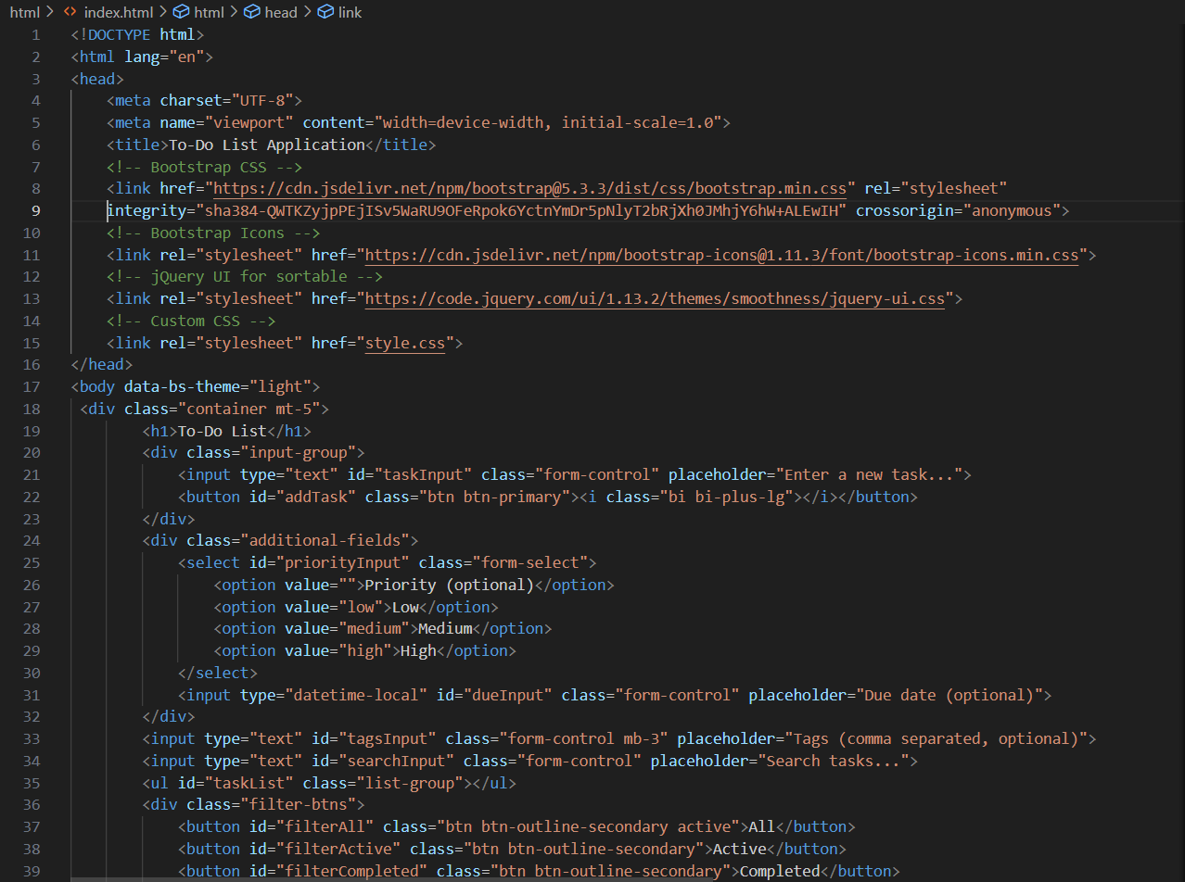

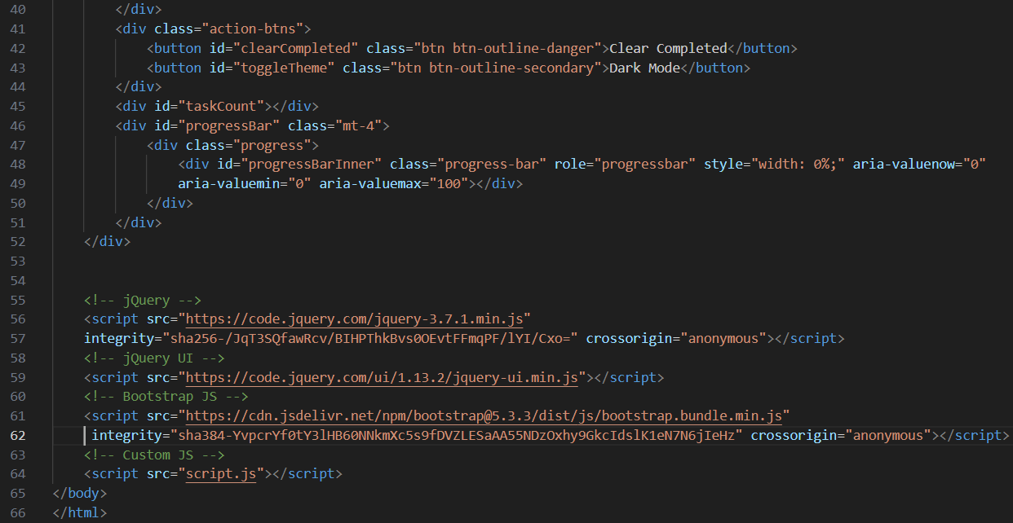

* **CSS Code:**

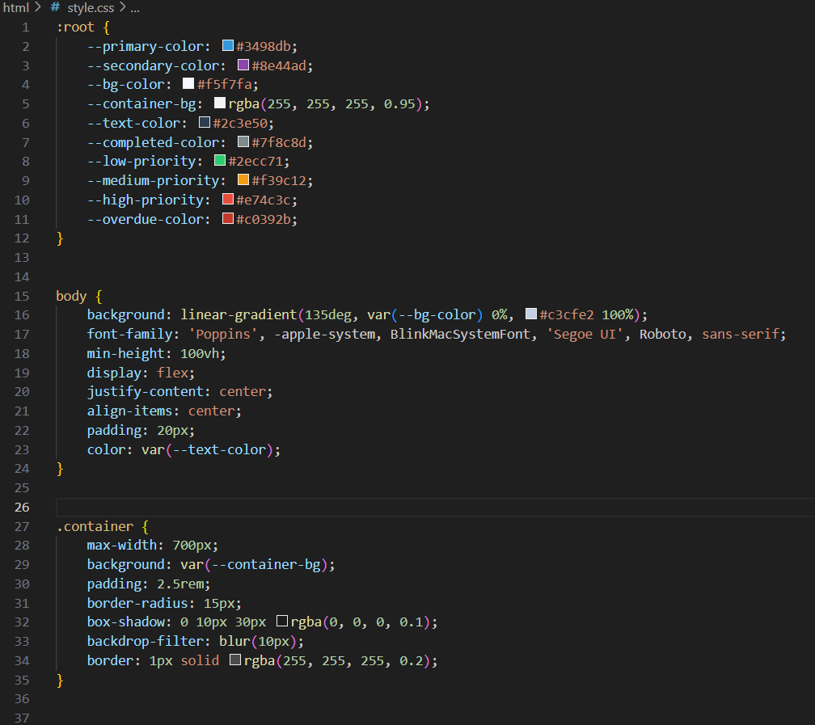

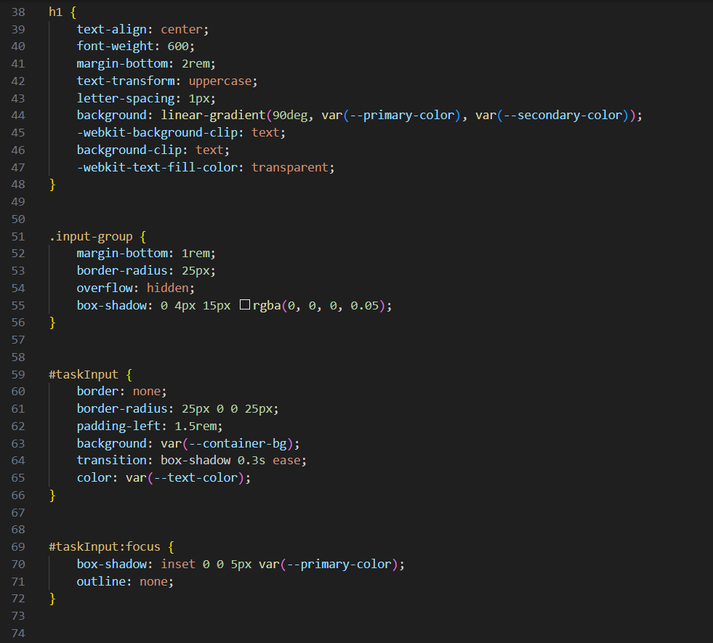

**`**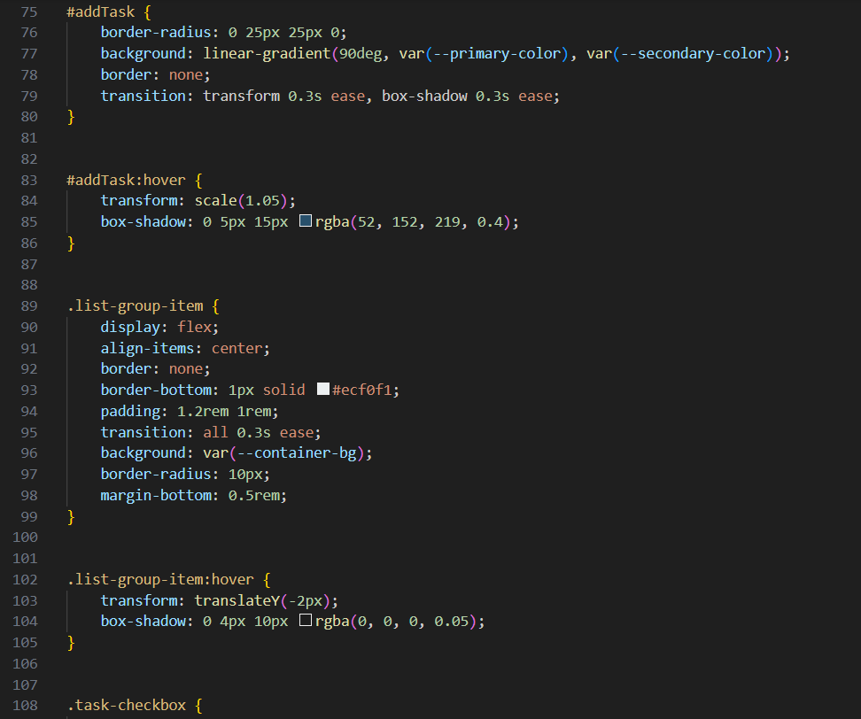

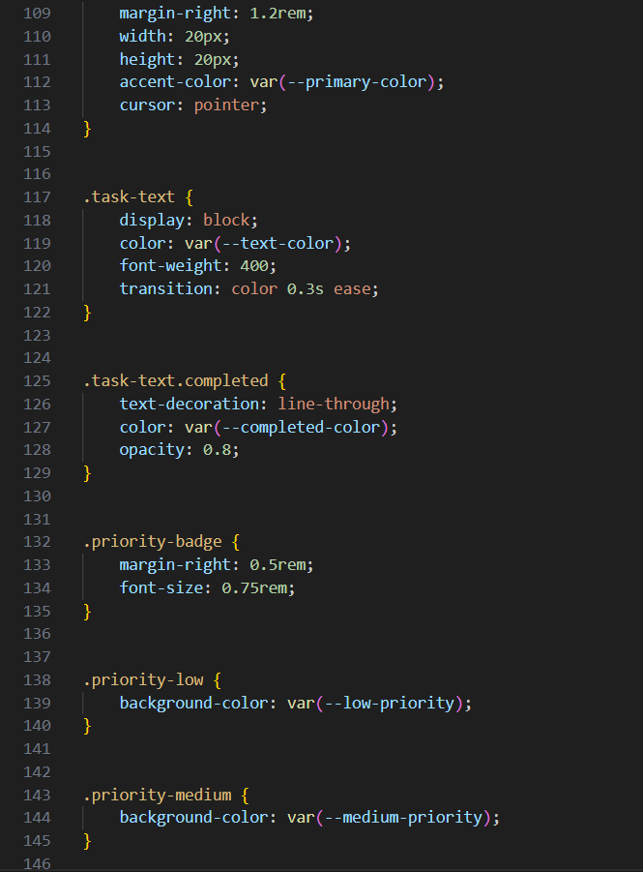

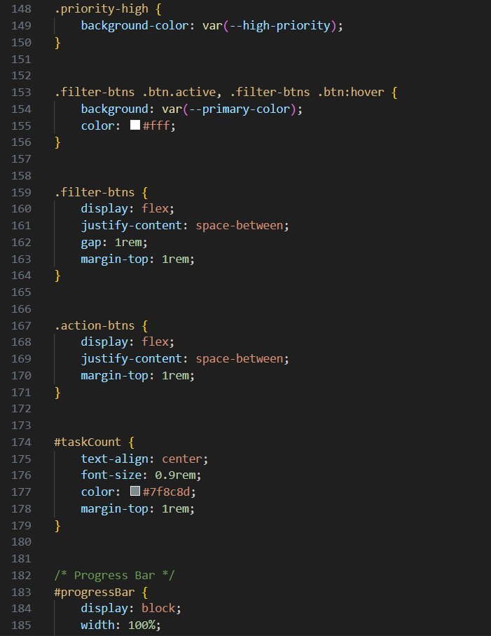

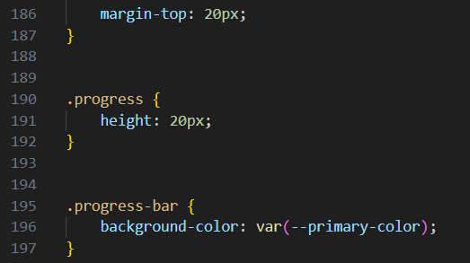

* **JavaScript Code:**

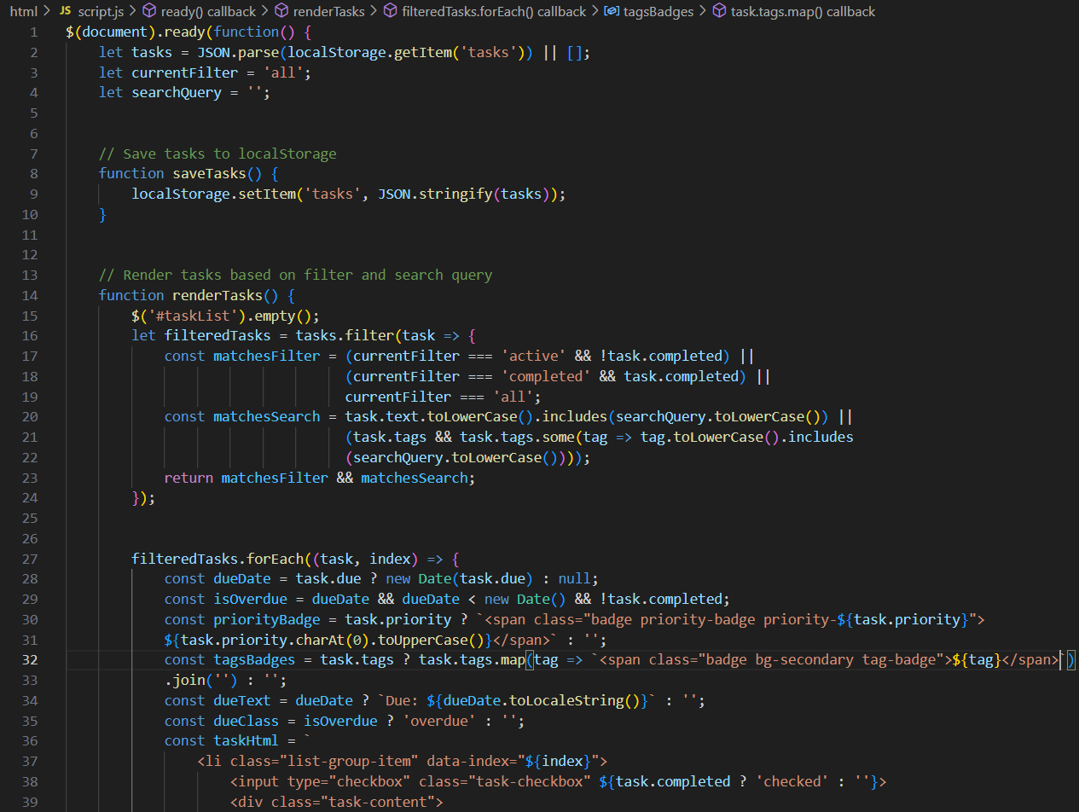

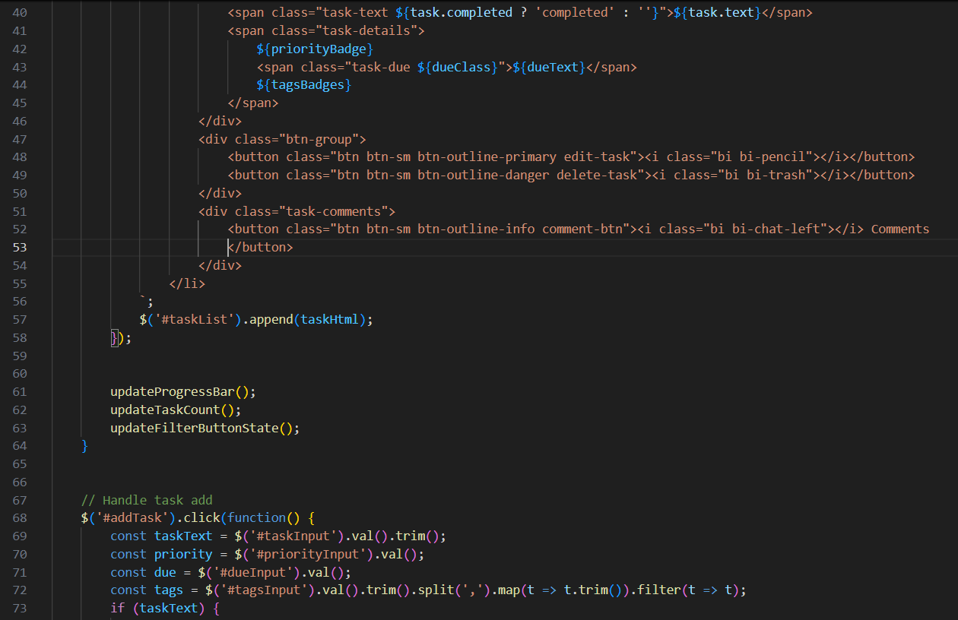

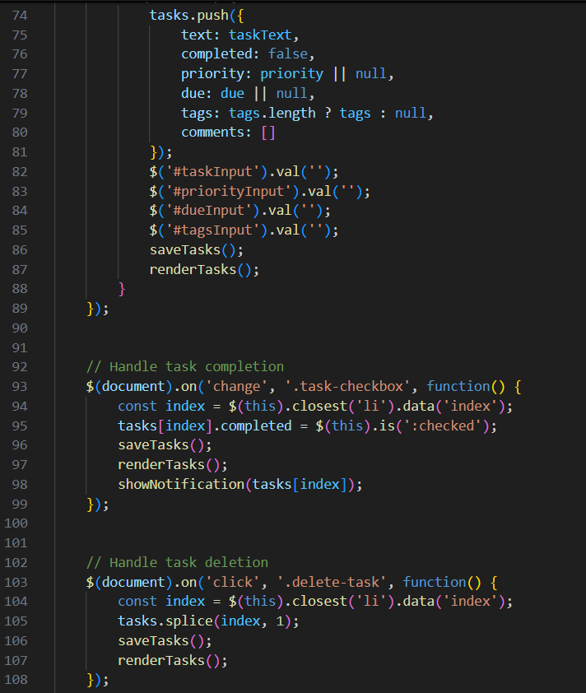

**16. Screenshots of Final Output Page :**

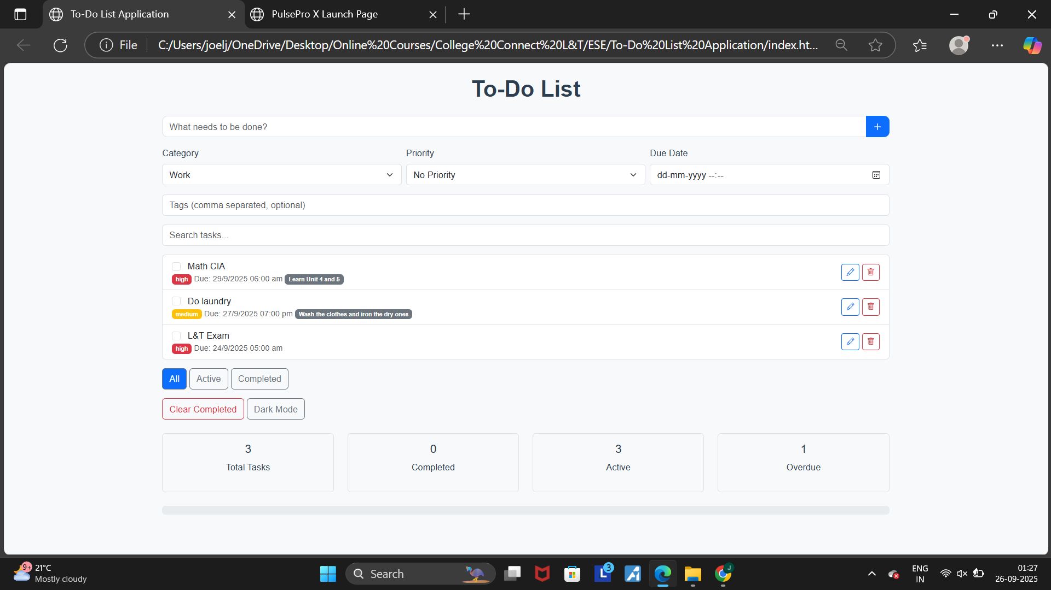

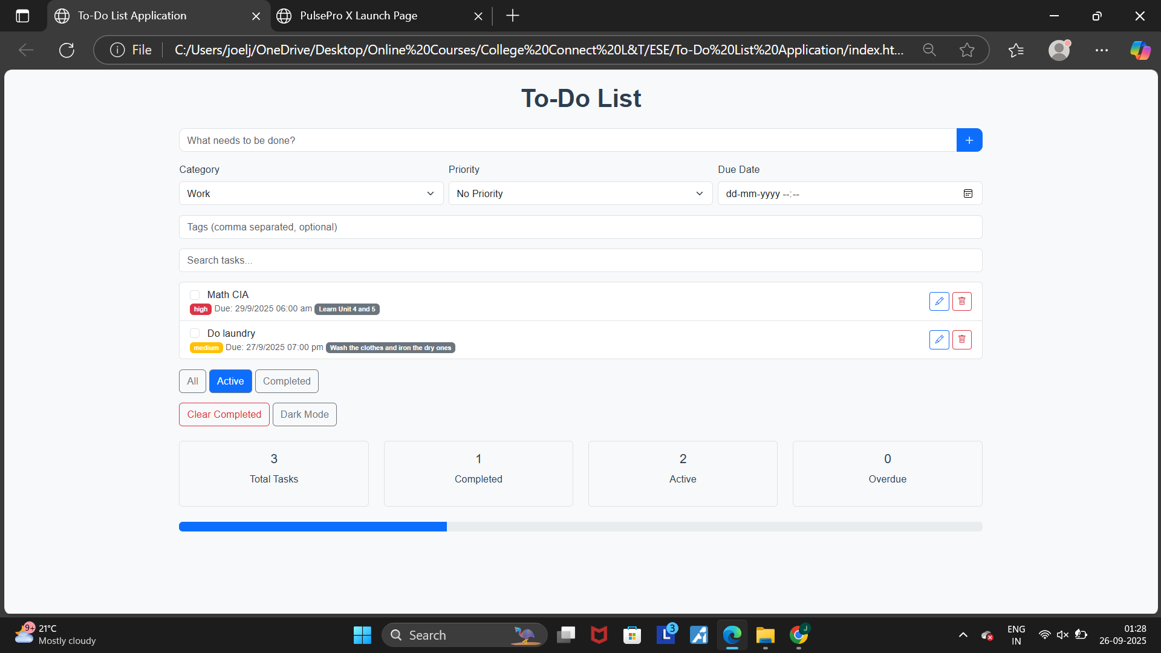

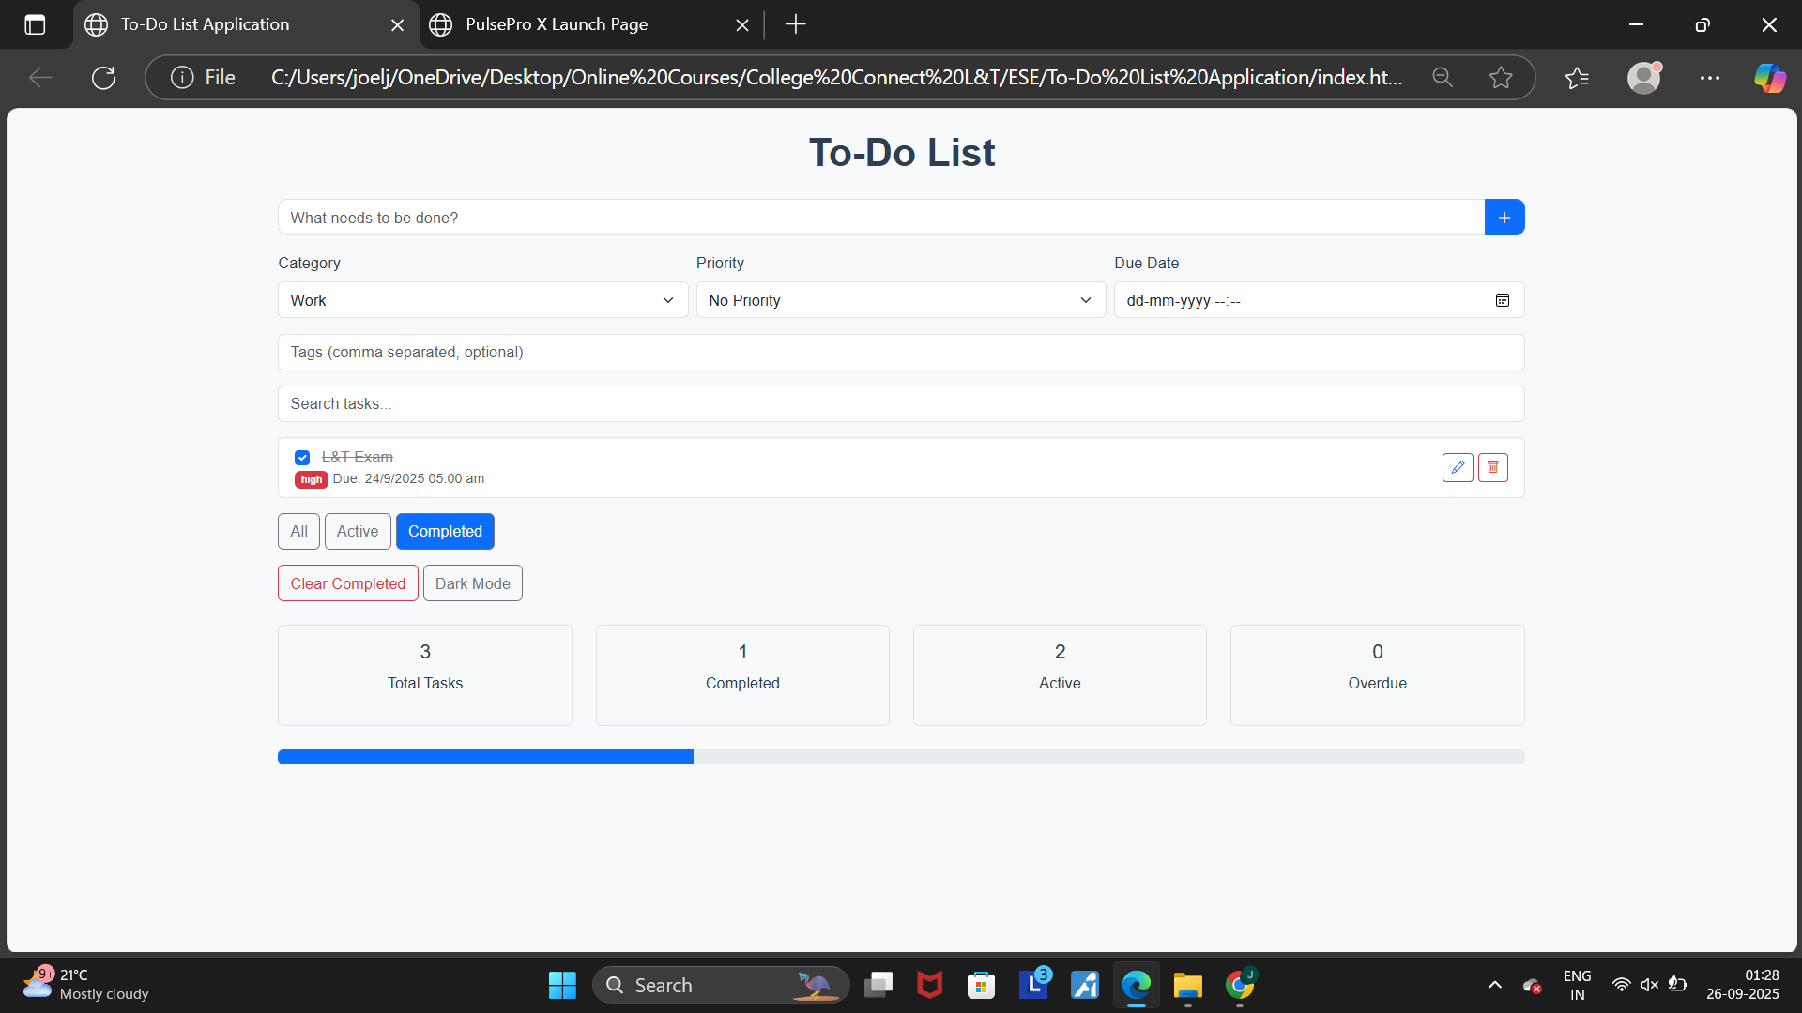

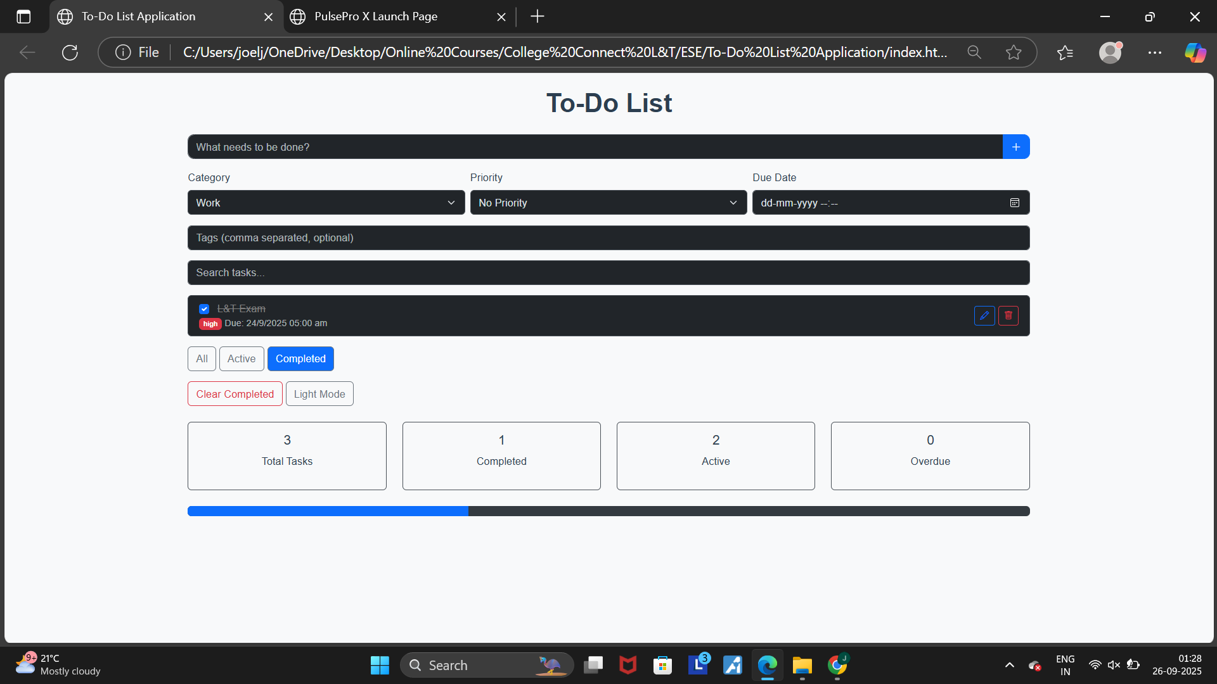

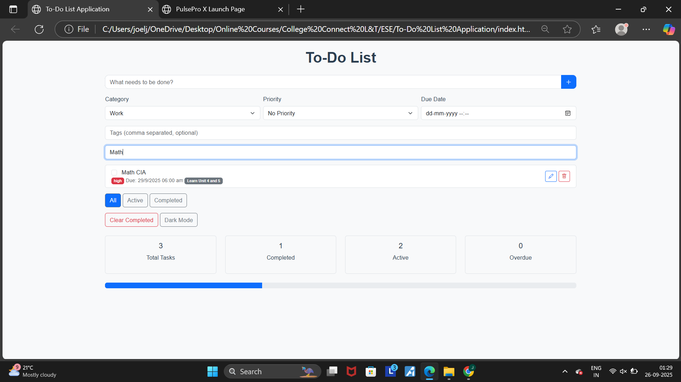

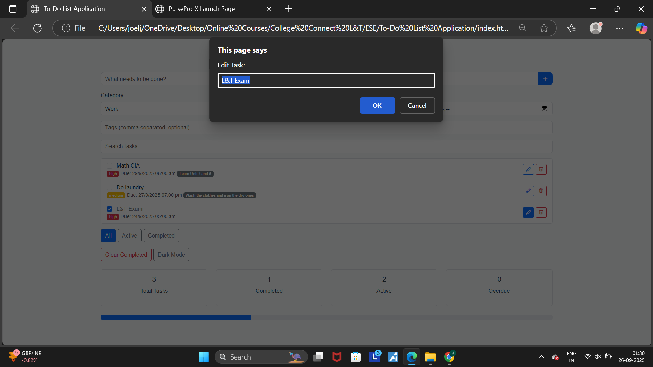

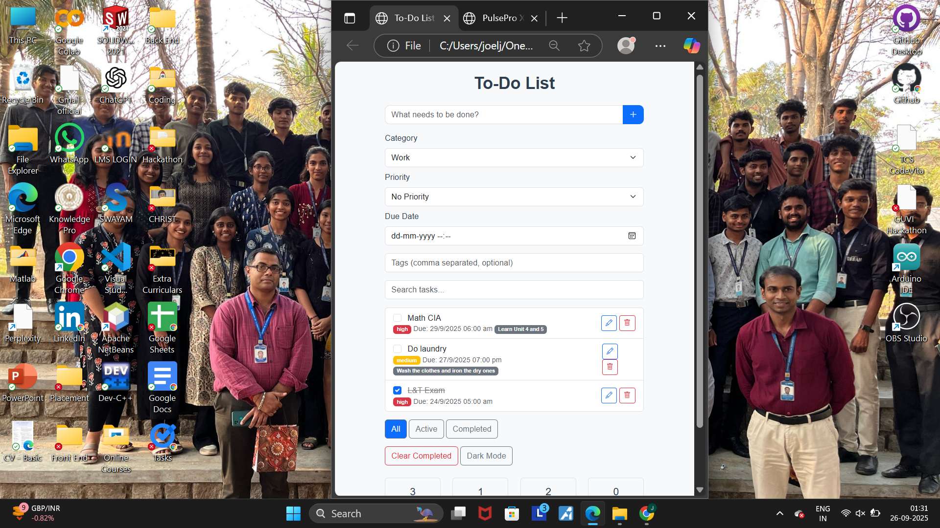

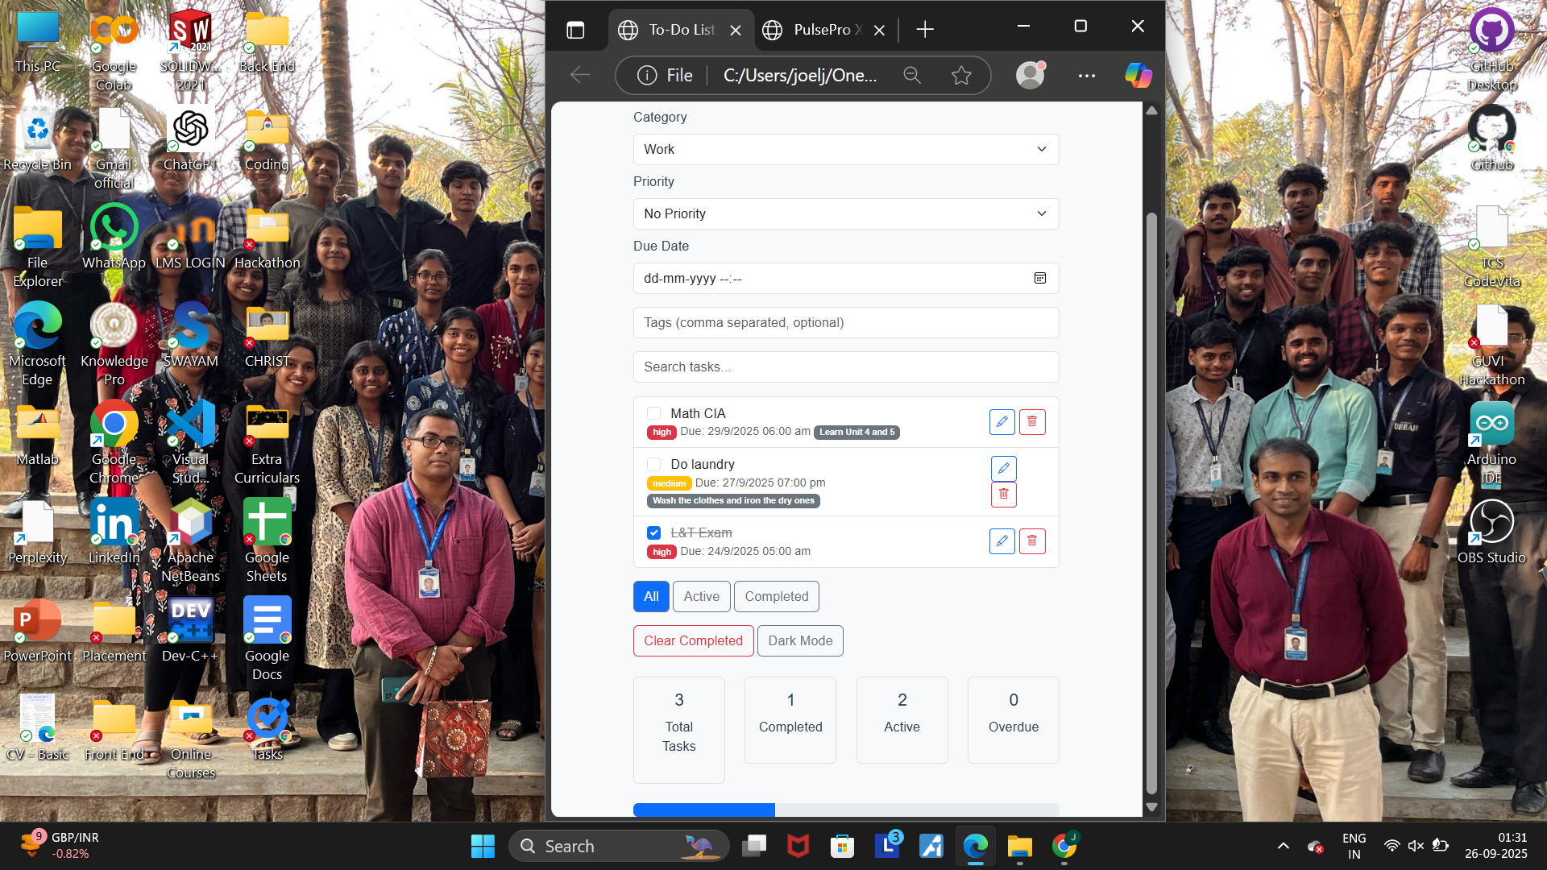

**17. Conclusion**

The To-Do List Application successfully demonstrates the integration of multiple front-end technologies into a practical productivity tool. With features like prioritization, categorization, filters, and theme toggling, it goes beyond a standard checklist app. The project showcases how responsive design, interactivity, and persistent storage can work together to create a polished user experience.

**18. References**

* L&T LMS: <https://learn.lntedutech.com/Landing/MyCourse>
* Bootstrap Documentation
* jQuery Documentation
* jQuery UI
* Google Fonts
* Bootstrap Icons